3rd Annual
CATCH THE BIRD
Predicted time
5K Run and 1Mile Kids Run/Walk

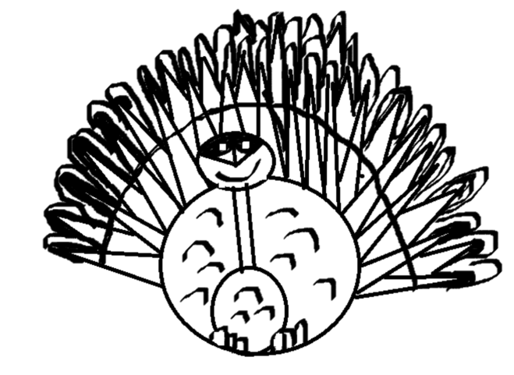
WHEN: SATURDAY, Nov. 22, 2014
WHERE: ONALASKA, WA
AGE DIVISIONS: NONE! This is a predicted time run so you can win if you are fast or slow, young or old.
AWARDS: First place overall female and male in the 5k and 1mile will receive custom trophies.
Turkeys will be awarded to the top runners with the time closest to their predicted time in the 5K and the 1mile.
All 1Mile finishers will receive participant ribbons.
THE COURSES: The courses will remain TOP SECERET until the morning of the race. NO WATCHES OR TIMING DEVICES ALLOWED!

ENTRY FEES: 1Mile Run/Walk (With Shirt) $15 Day of race$20 15yrs &under $10 Day of race$15
5K Run (With Shirt) $20 Day of race $25 15yrs &under $15 Day of race$20

NOTE: Bring a non-perishable food item (to be donated to the local food bank) and receive a $2 discount on your entry fee.

SCHEDULE OF EVENTS:
8:00am-9:00am Check in and registration
9:30am–START 5K Run and 1Mi Run/Walk
After final finisher - Awards and raffles

This event supports the Onalaska High School Track and Field Program as well as our community food bank. Proceeds will go to help in the purchase of equipment for the 2014/15 school year. We appreciate your support and hope you enjoy this event.

CONTACT INFO:
Carla Hoppie @ hoppiec@eou.edu
702-379-0249

Waiver and Release
I know that running, regardless of the distance, includes an element of risk. I and/or my child(ren) should not participate in the “Catch The Bird” unless medically able. I understand and assume any and all risks associated with participating in the “Catch The Bird” including, but not limited to illness, traveling to and from the event, falls, contact with other participants, the effects of the weather and surface conditions of the course.
Having read this waiver and knowing these facts and in consideration of the acceptance of my registration, I hereby for myself, my heirs, executors, administrators or anyone else who might claim on my behalf, covenant not to sue, and waive release and discharge Onalaska School District, The City of Onalaska, its officers, agents and employees, event officials, volunteers and any and all other sponsors, connected with the event, even though that liability my arise out of negligence or carelessness on the part of the persons or parties named in this waiver. I also understand and agree that event management may subsequently use, for publicity or promotional purposes, my name, my child’s name or pictures of me and/or my children participating in the “Catch The Bird” without liability or obligation to me.
I Agree to the Waiver and Release:

Signature___________________________________________Date_______________
(Parent or guardian signature if under 18)

REGISTRATION: PLEASE PRINT Name:______________________________________________________
Address:____________________________________________________
Phone: ______________________E-mail: _________________________
Age on race day: _______ Gender: ___Male ___Female
DISTANCE: check one ___ 5K Run ___ 1Mile Run/Walk PREDICTED TIME ______

SHIRT: Circle size - Youth S M L Adult M L X

ENTRY FEES: Pre-registration closes on November 19th
1Mile Run/Walk (With Shirt) $15 Day of race $20 15yrs & under $10 Day of race $15

5K Run (With Shirt) $20 Day of race $25 15yrs &under $15 Day of race $20

Make checks payable to: Onalaska School District

Mail your entry to: Onalaska High School, 540 Carlisle Ave, Onalaska, WA 98570

You may also drop your entry off @ Onalaska High School office by November 19th for pre-registration, or any time before November 22nd.

DIRECTIONS TO ONALASKA HIGH SCHOOL: 540 Carlisle Ave, Onalaska, WA 98570

I-5 North or South bound: Take exit --- (Hwy 508) head east past Jackson Highway for about ---miles turn left on Carlisle Ave & follow the signs to the school.
Coming from the east: follow highway 12 west turn right on ----travel aprox. – mi. to highway 508, continue on to Carlisle Ave & follow signs to the school.

